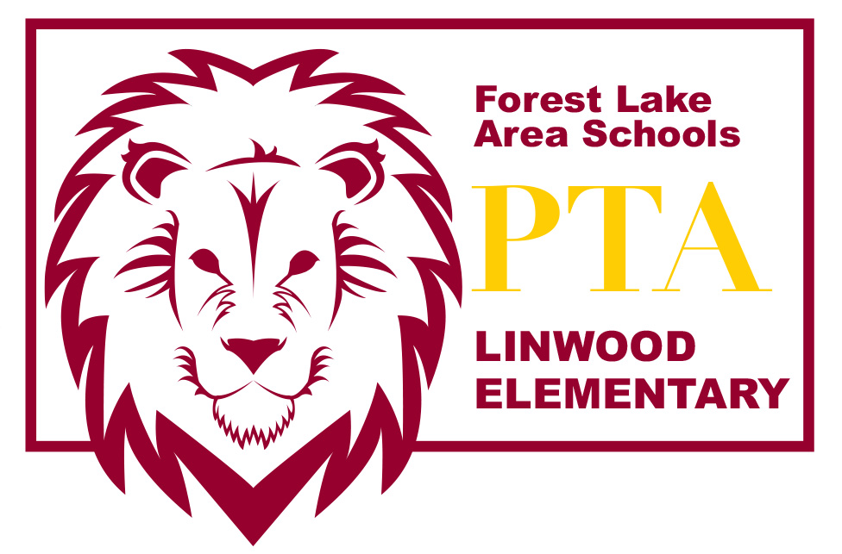
LINWOOD PTA MEETING AGENDA~ Jan 12, 2016

Introduction of PTA Board Members
- Amber Wiener – President
- Lea Bombard – Vice President
- Amber Hermanson – Secretary
- Tracy Crudo – Treasurer

Welcome & call meeting to order

Officer Reports
- Treasurer’s Report

Fundraiser Reports
- Box Tops for Education
- Labels for Education
- AmazonSmile

New Business
- The PTA donated to the YMCA Mentors Program
- PTA sponsored a pizza party for the 6th grade class for bringing in the most donations during the Student Council Food Challenge
- School Forest running a walk-a-thon fundraiser on Jan 30 at 5pm. Pledge sheets went home in Friday folders on Jan 8. Pledge forms are due January 25
- Books & Breakfast – PTA taking this over in February during I Love to Read month. Looking for a Committee Chairperson for this event
- LOST Fundraiser in February
- Carnival scheduled for Saturday, March 19. Looking for volunteers to help with planning. Schedule a planning meeting towards end of January

Principal’s Report

2015/16 PTA Membership Dues (National & MN PTA) are $10. Membership dues are paid annually. PTA members hold voting power on all vote items and will receive a complimentary Linwood t-shirt.

Please send any comments or questions to linwoodelempta@gmail.com or speak with any of the board members after the meeting. Thanks for coming today! We appreciate your support!

Stay up to date with what’s happening with the Linwood PTA:
http://linwoodpta.weebly.com
Facebook: Linwood MN PTA

