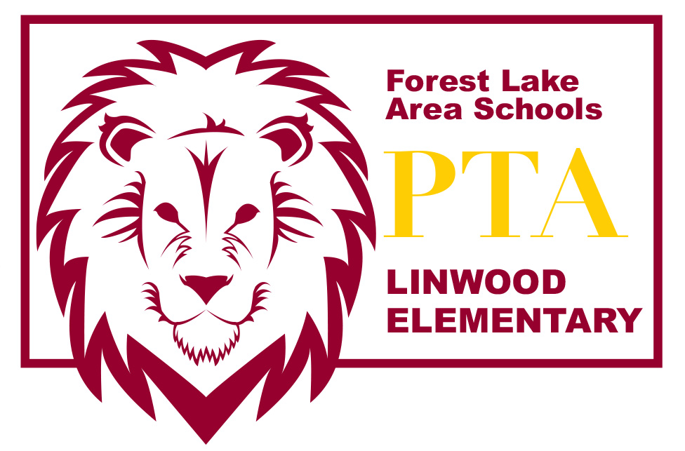
LINWOOD PTA MEETING AGENDA~ April 12, 2016

Introduction of PTA Board Members
- Amber Wiener – President
- Lea Bombard – Vice President
- Amber Hermanson – Secretary
- Tracy Crudo – Treasurer

Welcome & call meeting to order

Officer Reports
- Treasurer’s Report

Guest Speaker - Sean Sardeson
- School Forest Bench Plan – Eagle Scout Project Presentation

New Business
- Arts & Academic Fair
- Book Fair recap
- Carnival recap
- Field Trip Busing
- Currently accepting Treasurer Nominations. Elections will be at May meeting
- Teacher Appreciation Day – Chairperson: Rebecca Reid

Principal’s Report

Please send any comments or questions to linwoodelempta@gmail.com or speak with any of the board members after the meeting. Thanks for coming today! We appreciate your support!

Stay up to date with what’s happening with the Linwood PTA:
http://linwoodpta.weebly.com
Facebook: Linwood MN PTA

