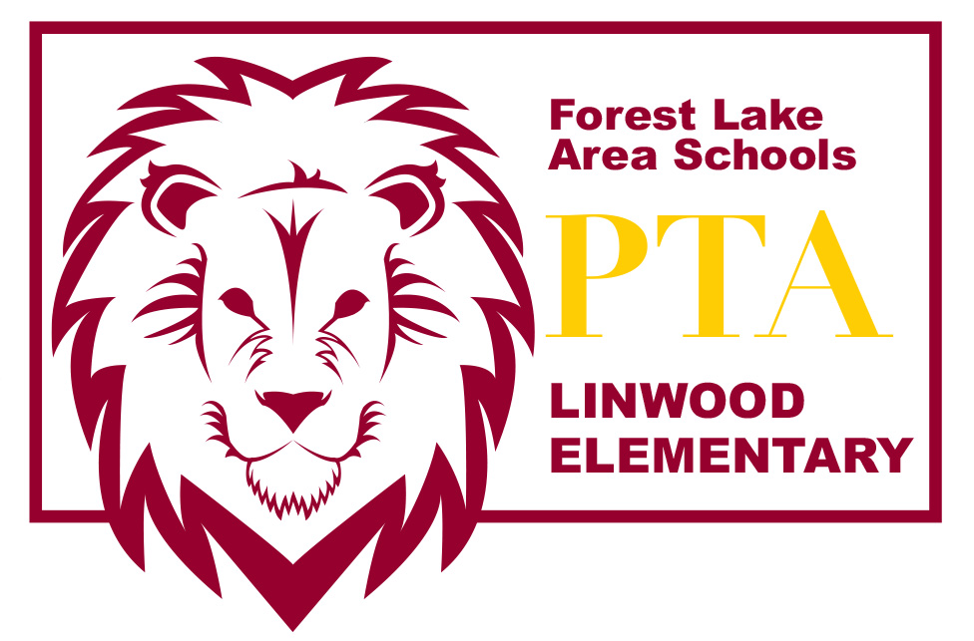
LINWOOD PTA MEETING AGENDA~ Dec 15, 2015

Introduction of PTA Board Members
- Amber Wiener – President
- Lea Bombard – Vice President
- Amber Hermanson – Secretary
- Tracy Crudo – Treasurer

Recap of School Year-To-Date Activities
- Color-A-Thon
- Book Fair
- Conference Meals
- SWISH update
- Moonlight Hike
- Turkey Bingo
- Adopt a Family (Christmas)
- Veteran’s Program
- Box Tops for Education
- Labels for Education
- AmazonSmile
- Scholastic News
- TIME Magazine
- GOOSE tickets

Upcoming Activities
- Student Council Food Challenge – sponsor pizza party to winning grade
- Moonlight Hike (Winter)
- LOST Fundraiser
- Books & Breakfast
- Book Fair
- Conference Meals
- Carnival
- Twins for Technology fundraiser
- Spring Fun Run??

Topics of Discussion
- Technology purchase
- YMCA Mentors Program

