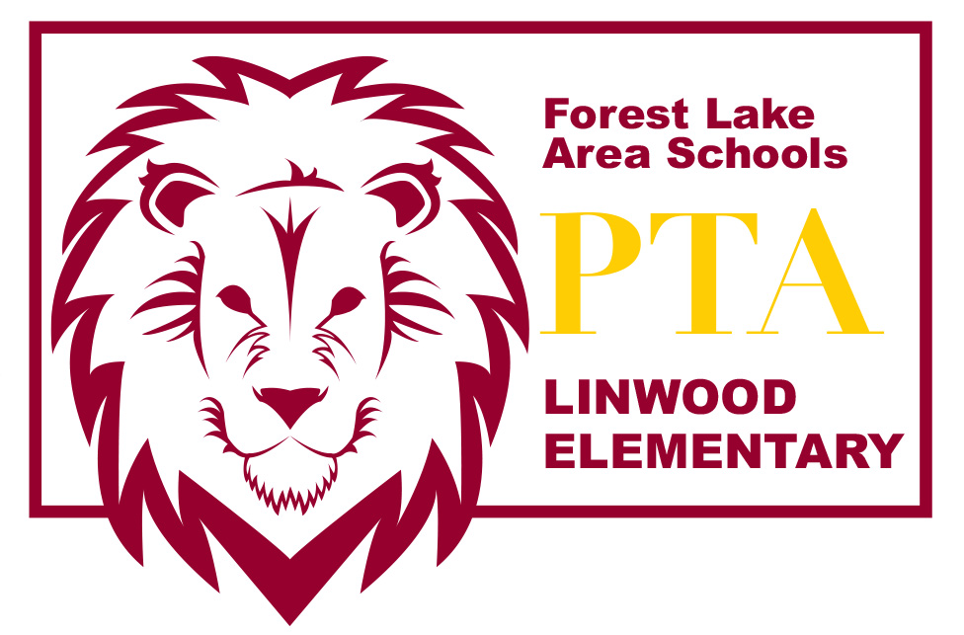
LINWOOD PTA MEETING AGENDA~ Oct 6, 2015

Introduction of PTA Board Members
- Amber Wiener – President
- Lea Bombard – Vice President
- Amber Hermanson – Secretary
- Tracy Crudo – Treasurer

Welcome & call meeting to order

Guest Speaker – Kathy Bystrom, Building the Future Together Vote Yes campaign

Fundraiser Items:
- Book Fair
  - Book Fair is scheduled the week of March 12
  - Amy Pesek is the Book Fair chairperson and is currently looking for volunteers to fill shifts. Contact Amy @ amypesek05@icloud.com

- Color-A-Thon
  - Color-A-Thon is scheduled for Saturday, October 10 at 2pm.
  - Students may continue to turn in donation packets; however, it is past the point where students will receive a t-shirt or prizes for any new donations made by cash/check or online
  - Still looking for volunteers to fill positions. Contact Amber Wiener if interested in volunteering @ amber.wiener@gmail.com

Announcements/Feedback

2015/16 PTA Membership Dues (National & MN PTA) are $10. Membership dues are paid annually. PTA members hold voting power on all vote items and will receive a complimentary Linwood t-shirt.

Please send any comments or questions to linwoodelempta@gmail.com or speak with any of the board members after the meeting. Thanks for coming today! We appreciate your support!

Stay up to date with what’s happening with the Linwood PTA:
http://linwoodpta.weebly.com
Facebook: Linwood MN PTA

