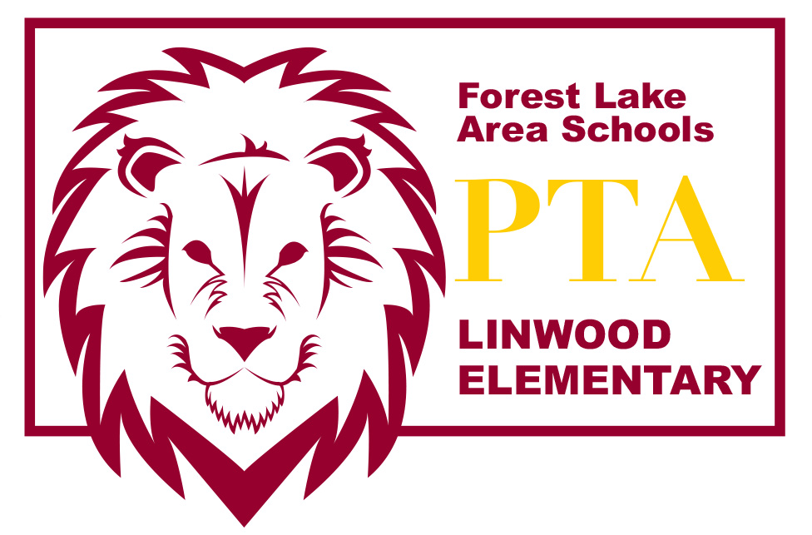
LINWOOD PTA MEETING ~ October 11, 2016

Introduction of PTA Board Members
- Amber Wiener – President
- Lea Bombard – Vice President
- Amber Hermanson – Secretary
- Christina Smentek – Treasurer

Welcome & call meeting to order

Treasurer’s Report

Color-A-Thon fundraiser Recap

Conferences & MEA Weekend
- PTA will not be providing conference meals this year

Book Fair

Box Tops for Education

Moonlight Hike (Fri, Oct 28)

SWISH Fluoride Program
- Very low number of sign ups and lack of volunteers to distribute

Principal’s Report

Please send any comments or questions to linwoodelempta@gmail.com or speak with any of the board members after the meeting. Thanks for coming tonight! We appreciate your support!

http://linwoodpta.weebly.com | Facebook: Linwood MN PTA

