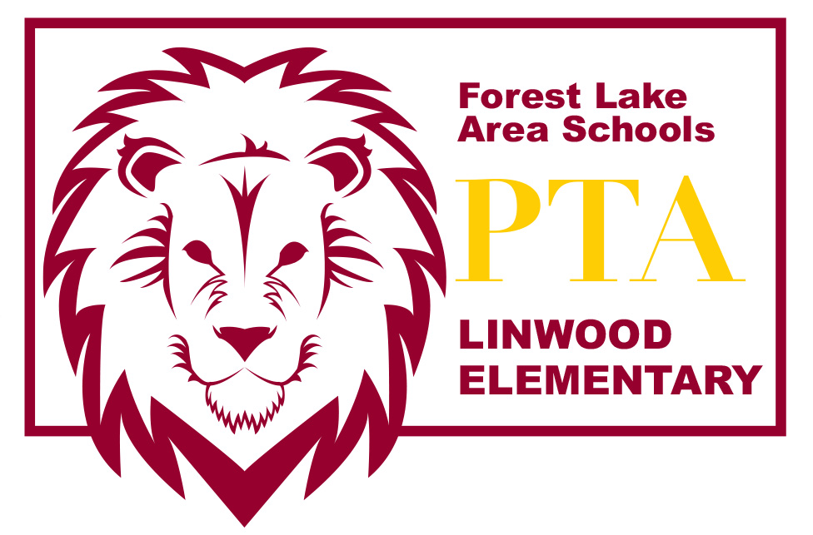
LINWOOD PTA MEETING ~ September 13, 2016

Introduction of PTA Board Members
- Amber Wiener – President
- Lea Bombard – Vice President
- Amber Hermanson – Secretary
- Christina Smentek – Treasurer

Welcome & call meeting to order

Treasurer’s Report

Color-A-Thon fundraiser (Sat. Oct 8 @ 3pm)
- Planning committee members and volunteers needed
- Kids coming home with fundraising materials this week

Labels for Education
- Purchased playground equipment, calculators (extras for 5th & 6th Grade classrooms) and electric pencil sharpeners with points set to expire this year

Box Tops for Education

PBIS T-shirts for 2016/17 school year
- Shirts were distributed last Friday

Book Fair – Lea Bombard

School Forest – Emily Raml
- School Forest is up for a TEFFLA grant. Show your support at the annual fall event:
Thursday, Sept. 15 from 5:30-8:00pm | Waldoch Farm, 8174 Lake Drive, Circle Pines, MN 55014

Event includes wine & beer tasting, local food vendors, live music by the FLHS string quartet, raffle items, live auction & other fun, family activities

Moonlight Hike (Fri, Oct 28)

Volunteer Forms
- Going home in Friday Folders this week

SWISH Fluoride Program
- Going home in Friday Folders this week. Will start beginning of October
- Need volunteers to distribute SWISH to classrooms Friday mornings before school

Principal’s Report

Please send any comments or questions to linwoodelempta@gmail.com or speak with any of the board members after the meeting. Thanks for coming tonight! We appreciate your support!

http://linwoodpta.weebly.com | Facebook: Linwood MN PTA

